Test Application: https://demo.nopcommerce.com/
Module: User Registration
Date: July 20, 2025

Test case id: TC01

Test case name : Register New User

Pre-Condition:
- Navigate to https://demo.nopcommerce.com

Steps:
- Click on "Register" link in the top navigation
- Select gender (Male/Female)
- Enter valid first name (e.g., "Abc")
- Enter valid last name (e.g., "Abc")
- Enter valid email address (e.g., "Abc@example.com")
- Enter valid password (minimum 6 characters, e.g., "Password123")
- Enter the same password in "Confirm password" field
- Click "Register" button
Expected Result:
User should be registered successfully and redirected to home page.

Actual Result:
User registered successfully

Status: Pass

Screenshot:
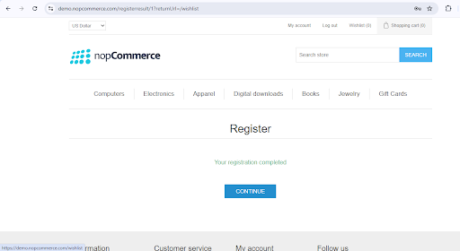

Test case id:TC02

Test case name : Invalid email format

Pre-Condition:
- Navigate to https://demo.nopcommerce.com

Steps:
- Click on "Register" link in the top navigation
- Select gender (Male/Female)
- Enter valid first name (e.g., "Abc")
- Enter valid last name (e.g., "Abc")
- Enter Invalid email address (e.g., "abc.example.com")
- Enter valid password (minimum 6 characters, e.g., "Password123")
- Enter the same password in "Confirm password" field
- Click "Register" button
Expected Result:
Error message should be display.

Actual Result:
Please enter a valid email address” validation message displayed

Status: Pass

Screenshot:
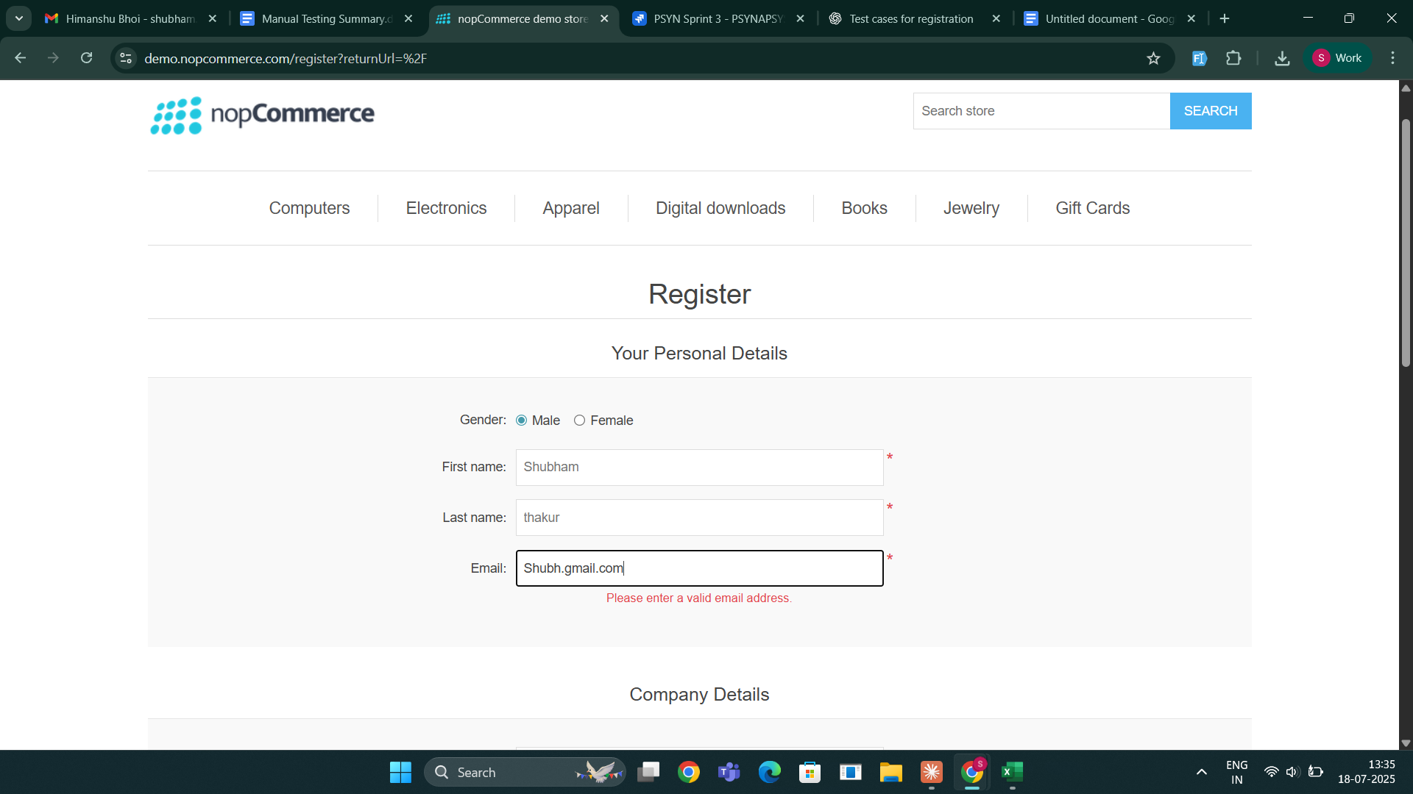

Test case id: TC03

Test case name :Blank required fields

Pre-Condition:
- Navigate to https://demo.nopcommerce.com/

Steps:
- Click on "Register" link in the top navigation
- Select gender (Male/Female)
- Leave First name field blank
- Enter valid last name (e.g., "Abs")
- Enter valid email address (e.g., "abc@example.com")
- Enter valid password (minimum 6 characters, e.g., "Password123")
- Enter the same password in "Confirm password" field
- Click "Register" button
Expected Result:
Mandatory field error should be display.

Actual Result:
First name is required.

Status: Pass

Screenshot:
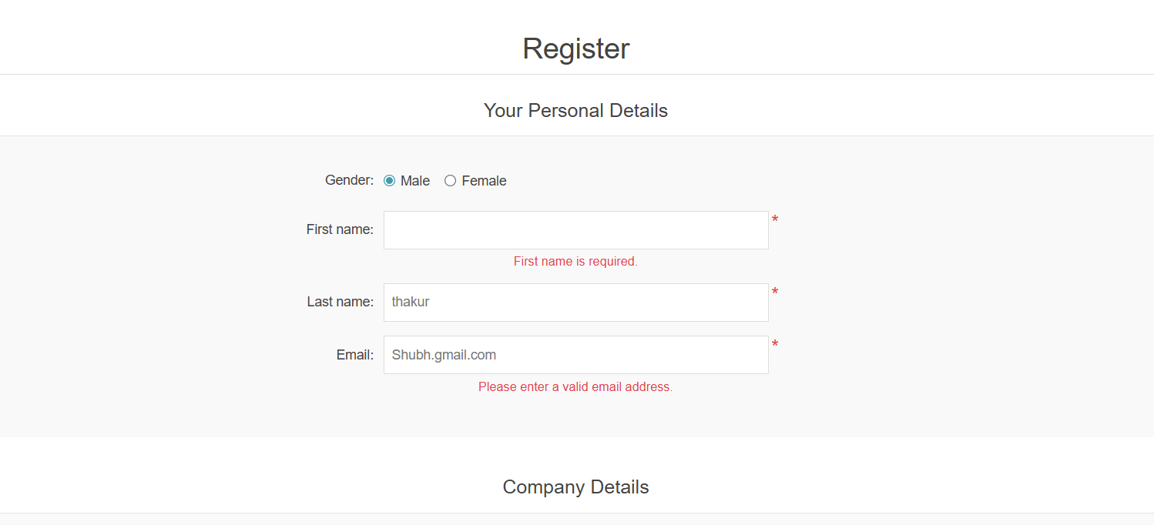

Test case id: TC04

Test case name : Password and confirm password mismatch

Pre-Condition:
- Navigate to https://demo.nopcommerce.com/

Steps:
- Click on "Register" link in the top navigation
- Select gender (Male/Female)
- Enter valid first name (e.g., "Sarah")
- Enter valid last name (e.g., "Morrison")
- Enter valid email address (e.g., "sarah.morrison@example.com")
- Enter valid password (minimum 6 characters, e.g., "Password123")
- Enter the different password in "Confirm password" field
- Click "Register" button
Expected Result:
- Error message should be display “password mismatch”.

Actual Result:
- The password and confirmation password do not match” validation message displayed
Status: Pass

Screenshot:
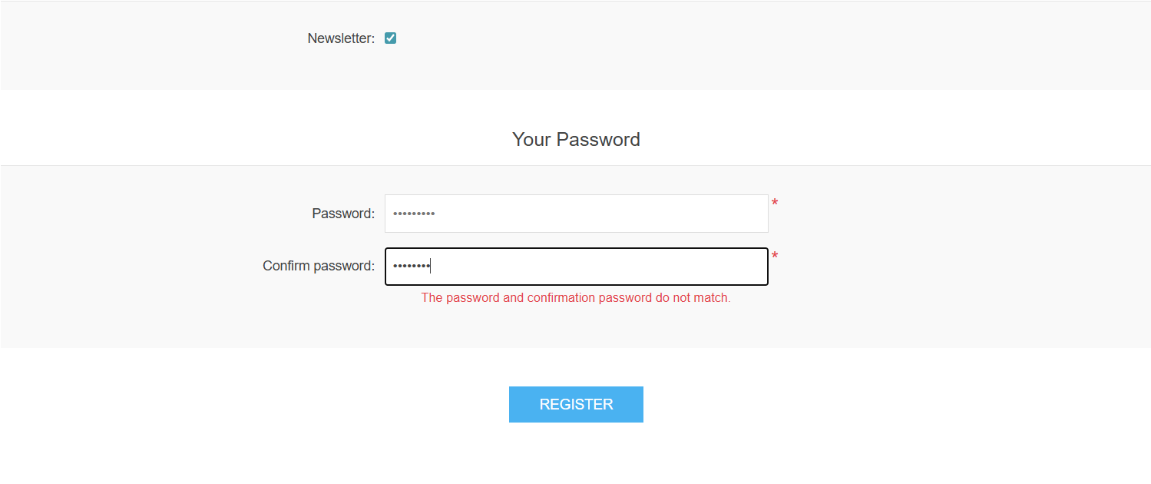
Test case id: TC05

Test case name : Already registered email

Pre-Condition:
- Navigate to https://demo.nopcommerce.com/

Steps:
- Click on "Register" link in the top navigation
- Select gender (Male/Female)
- Enter valid first name (e.g., "Abc")
- Enter valid last name (e.g., "Abc")
- Enter valid email address (e.g., "abc@example.com")
- Enter valid password (minimum 6 characters, e.g., "Password123")
- Enter the same password in "Confirm password" field
- Click "Register" button
Expected Result:
- Already registered email error message should be display

Actual Result:
- error message display

Status: Pass

Screenshot:
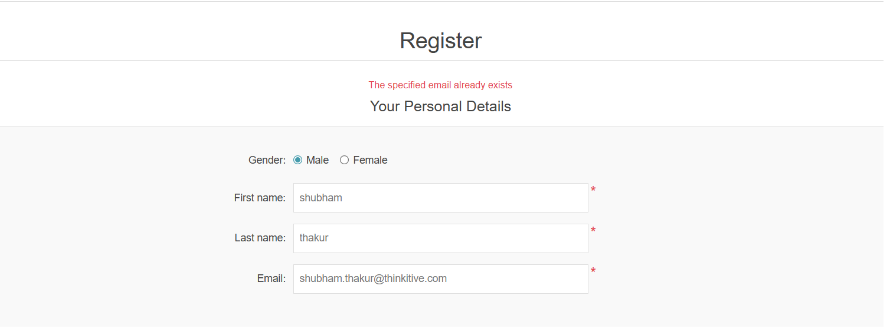

Test case id: TC06

Test case name : login with valid credentials

Pre-Condition:
- Navigate to https://demo.nopcommerce.com/

Steps:
- Click on "login" link in the top navigation
- Enter valid email address (e.g., "Abc@example.com")
- Enter valid password (minimum 6 characters, e.g., "Password123")
- Click "login" button
Expected Result:
User should be registered successfully login and redirected to home page.

Actual Result:
User login successfully

Status: Pass

Test case id: TC07

Test case name : login with in valid email

Pre-Condition:
- Navigate to https://demo.nopcommerce.com/

Steps:
- Click on "login" link in the top navigation
- Enter Invalid email address (e.g., "Abc@example.com")
- Enter valid password (minimum 6 characters, e.g., "Password123")
- Click "login" button
Expected Result:
User should not be able login successfully .

Actual Result:
User not able login successfully.

Status: Pass

Screenshot:
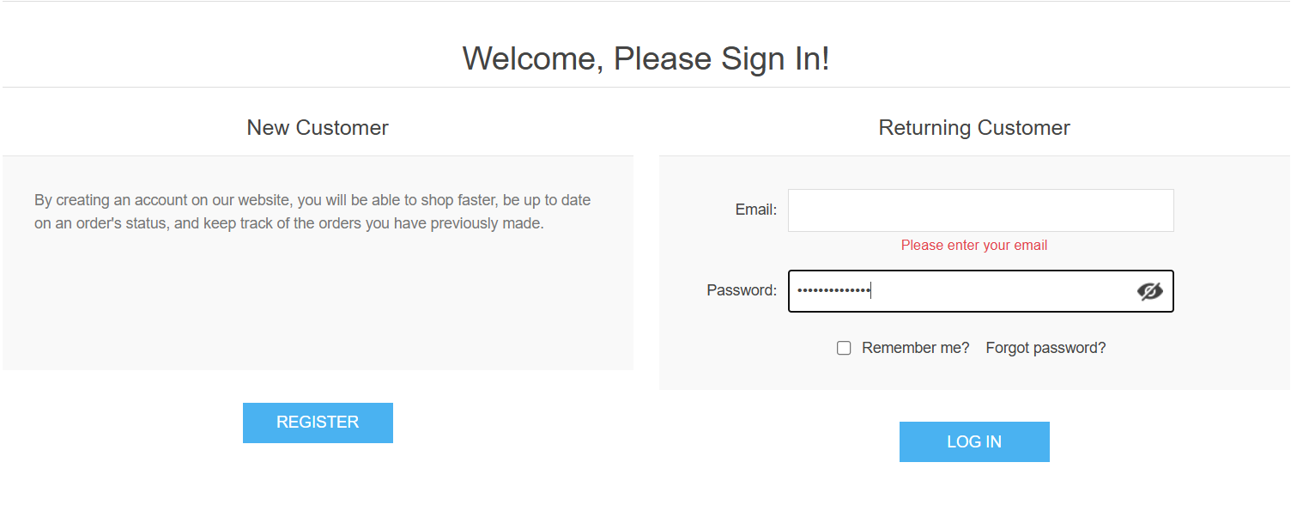

Test case id: TC08

Test case name : login with invalid password
Pre-Condition:
- Navigate to https://demo.nopcommerce.com/

Steps:
- Click on "login" link in the top navigation
- Enter valid email address (e.g., "Abc@example.com")
- Enter Invalid password (minimum 6 characters, e.g., "Password123")
- Click "login" button
Expected Result:
User should not able be successfully.

Actual Result:
User not able login successfully

Status: Pass

Screenshot:
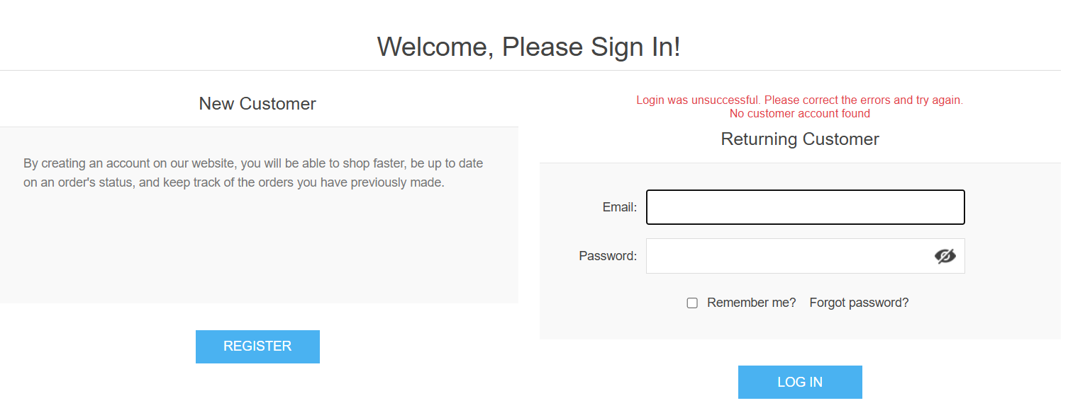

Test case id: TC09

Test case name : Login with Blank Fields
Pre-Condition:
- Navigate to https://demo.nopcommerce.com/

Steps:
- Click on "login" link in the top navigation
- Click "login" button
Expected Result:
Validation messages for required fields.

Actual Result:
Validation errors shown

Status: Pass

Screenshot:


Test case id: TC010

Test case name : User should logout

Pre-Condition:
- Navigate to https://demo.nopcommerce.com/

Steps:
- Click on "login" link in the top navigation
- Enter valid email address (e.g., "Abc@example.com")
- Enter valid password (minimum 6 characters, e.g., "Password123")
- Click”login” button
- Click "logout" button
Expected Result:
User should be logout successfully.

Actual Result:
User logout successfully

Status: Pass

